Detection and Morphological Segmentation of the Foramen Palatinum Majus on CBCT Images Using the MedSAM Deep Learning Model
Dilara Kara¹, İzzet Ahmet?, Ahmet Emre Usta?, Tunca Doğan², Aydın Kaya², Ali Seydi Keçeli², Serdar Uysal¹
¹Hacettepe University, Faculty of Dentistry, Department of Oral and Maxillofacial Radiology, Ankara, Turkey
²Hacettepe University, Faculty of Engineering, Department of Computer Engineering, Ankara, Turkey

Corresponding Author
Name: Dilara Kara
Affiliation: Hacettepe University, Faculty of Dentistry, Department of Dentomaxillofacial Radiology
Address: Hacettepe University, Faculty of Dentistry, Department Dentomaxillofacial Radiology
Sıhhiye, 06230 Ankara, Turkey
Email: [dilarakara@hacettepe.edu.tr]
Phone: [+905458698969]

Abstract
Objective
This study aimed to evaluate the performance of the MedSAM deep learning algorithm for the automatic segmentation of the Foramen Palatinum Majus (FPM), a small and low-contrast anatomical structure, on cone-beam computed tomography (CBCT) images.
Materials and Methods
This retrospective study utilized CBCT images from 500 patients obtained from the archives of the Department of Dentomaxillofacial Radiology at Hacettepe University Faculty of Dentistry. All scans were acquired using the i-CAT Next Generation system. FPM structures were manually segmented using 3D Slicer software and morphologically classified into oval, round, or slit types. Segmentation masks were generated in NIfTI format. Preprocessing steps included image sharpening and resolution standardization. The dataset was divided into 80% for training and 20% for validation. Model training was conducted using the Dice loss function and Adam optimizer, with a learning rate of 0.001.
Results
Of the patients, 66.6% were female and 33.4% male, with a mean age of 43.55 years. The most common morphological type was oval, identified in 75.4% of right and 79.4% of left FPMs. The most frequent combination was "left oval – right oval." The model demonstrated a significant improvement in segmentation performance throughout training. The Dice coefficient increased from 0.710 to 0.861, precision from 0.817 to 0.903, and recall from 0.627 to 0.822. As the number of epochs increased, false positive rates decreased while true positive detections improved.
Conclusion
The MedSAM algorithm achieved high accuracy in the morphological segmentation and classification of the FPM in CBCT images. Our findings show that MedSAM can help less experienced clinicians make more accurate decisions. They also indicate that AI tools may play an active role in improving the radiological decision-making process in dentistry.
Keywords
Deep learning; Foramen palatinum majus; Cone-beam computed tomography; MedSAM; Artificial intelligence

INTRODUCTION
Cone-beam computed tomography (CBCT) has become widely used in dentistry in recent years because it can provide clear, three-dimensional images of the maxillofacial region. Compared to traditional x-rays, it offers higher resolution with reduced distortions caused by metal which allows bones and anatomical structures to be viewed more accurately. Another advantage of CBCT is isotropic voxels, which provide the same level of detail in every direction. These voxels make it possible to evaluate selected areas with high precision. For these reasons, CBCT is considered an essential tool for many procedures including periodontal assessments, implant planning, and maxillofacial surgeries (1-3).
Identifying small and low-contrast anatomical structures on CBCT scans can be time-consuming and may vary between observers. One such structure is the Foramen Palatinum Majus (FPM), a small but important opening located on the posterolateral part of the hard palate. At the junction of the palatine bone and the maxillary bone, the greater palatine nerve (n. palatinus major) and artery (a. palatina major) pass through this foramen to branch into the palatal tissues. The FPM provides sensory innervation and blood supply to the mucosa covering the hard palate and also plays a key role in supporting circulation to adjacent soft palate regions. Because it is not easily visible on CBCT images, accurate identification of the FPM requires good anatomical knowledge and careful image assessment (4). Accurate identification and evaluation of the FPMs are important for many dental and surgical procedures. Its location must be precisely known when administering palatal nerve blocks targeting the greater palatine nerve. The FPM also plays a key role in procedures such as harvesting free gingival grafts, removing palatal tumors or lesions, and performing reconstructive surgeries in patients with cleft lip and palate. In addition, its position should be carefully considered during palatal tori removal and complex maxillofacial surgeries, including Le Fort I osteotomies, where the risk of damage to nearby blood vessels and nerves is significant (5-8). In CBCT studies, FPM is commonly classified into three shapes: round, ovoid, or slit-like. This classification may seem simple, but it holds clinical importance in procedures where even small anatomical differences can lead to complications. Being aware of these variations in advance helps clinicians adjust their surgical or anesthetic techniques appropriately, reducing the risk of nerve injury or inadequate anesthesia. Taşsöker et al. (9), reported that the ovoid shape of the FPM was the most common type in both dentate (76.8%) and edentulous (77.6%) individuals, while the slit-shaped type was observed to be quite rare. Similarly, Akkitap (10) found that elongated oval foramina oriented along the anteroposterior axis were predominant (64.1%) and noted that these shapes were influenced by factors such as age and sex. These variations also help establish classification criteria for training artificial intelligence models designed for automatic segmentation of the FPM on CBCT images.
In recent years, artificial intelligence (AI) has become increasingly integrated into dental practice. Notable research and applications have emerged particularly in fields such as oral, dental, and maxillofacial radiology, periodontology, endodontics, and orthodontics. Within radiology, Convolutional Neural Networks (CNNs) have demonstrated significant utility in supporting diagnostic processes that require complex image interpretation. These algorithms have been effectively utilized to automate various diagnostic tasks, including the identification of tooth boundaries, detection of supernumerary teeth, and localization of vertical root fractures. In addition, CNN-based systems have demonstrated promising capabilities in detecting apical lesions, screening for osteoporosis (11), and even assisting in the recognition of systemic diseases such as Sjögren’s syndrome (12). These findings underscore the broad clinical applicability of recent technological advancements in artificial intelligence.
In addition to dental radiography, CNN-based models have been successfully implemented in other imaging modalities, such as ultrasonography, where they contribute to more standardized and efficient diagnostic workflows. These systems not only enhance clinical decision-making but also help reduce the diagnostic workload of healthcare professionals by automating repetitive and time-consuming evaluation tasks (13). In a study conducted by Orhan et al. (14), a deep learning model trained on CBCT images successfully detected 142 out of 153 periapical lesions, demonstrating strong potential for clinical implementation. Similarly, Hiraiwa et al. (12) developed an AI-based diagnostic tool for identifying Sjögren’s syndrome on CT scans, which achieved an accuracy of 96%. Lee et al. (11) also reported high diagnostic performance, applying a CNN-based model to panoramic radiographs for osteoporosis screening and attaining an accuracy of 98.5%. These findings collectively underscore the growing applicability of AI technologies across various dental imaging modalities.
In this study, we used MedSAM, a deep learning algorithm based on the Segment Anything Model (SAM) architecture and adapted to medical imaging. Trained on universal visual elements, MedSAM is a next-generation model capable of achieving high accuracy even with a small amount of labeled data. MedSAM is particularly successful in distinguishing small anatomical structures. Thanks to its Transformer-based structure and ability to evaluate a broad visual context, it can draw clear boundaries even in low-contrast areas. The algorithm uses a loss function composed of a combination of Binary Cross-Entropy (BCE) and Dice loss. BCE ensures the correct prediction of each voxel, while Dice accurately represents the overall structure and overlap of the segmented area. The combined use of these two metrics enhances MedSAM's performance in various medical imaging applications such as MRI and ultrasound.
Additionally, MedSAM's support for interactive labeling holds the potential to minimize human errors inherent in manual segmentation, positioning it as a potential decision-support mechanism in clinical workflows (15, 16). This study aims to evaluate the performance of the MedSAM algorithm in the automatic segmentation and morphological classification of the FPM in CBCT images. Accordingly, the study's hypothesis posits that the MedSAM algorithm can accurately segment the FPM an anatomically small and low-contrast structure within CBCT images and that this accuracy will be statistically significant, as demonstrated by performance metrics such as Dice coefficient, precision, and recall.

MATERIALS AND METHODS
For this methodological study, ethical approval was obtained from the Non-Interventional Clinical Research Ethics Committee of Hacettepe University Institute of Health Sciences, with decision number SBA 24/334, dated March 5, 2024. The study was conducted using images retrieved from the archives of the Department of Dentomaxillofacial Radiology, Faculty of Dentistry, Hacettepe University. Access to the imaging data was restricted solely to the research team.
Selection of Images and Labeling Process
CBCT images acquired between 2015 and 2023 were used to segment the FPM located in the hard palate region. A total of 500 CBCT datasets, in which the FPM was clearly visualized, were included in the study. These images were obtained using the i-CAT Next Generation (Imaging Sciences International, Hatfield, PA, USA) device, with parameters of 120 kVp, 5 mA, 14.7–17.8 seconds scanning time, and a field of view (FOV) of 16×(8–13) cm. On average, each patient’s dataset consisted of 526 axial slices, with approximately 39 slices displaying the FPM.
CBCT images exhibiting diagnostic quality degradation due to factors such as patient movement, metal artifacts, incomplete or insufficient volumetric data, FOV selection errors, and suboptimal imaging parameters (kVp, mA) were excluded. Only images with complete and diagnostically sufficient visualization of the anatomical region were included in the analysis.
Manual segmentation procedures were performed by a single observer (D.K.) specialized in dentomaxillofacial radiology, using the Segment Editor module of the 3D Slicer software (Figure 1, Figure 2). Segmentation was conducted slice by slice without the use of automated interpolation or fill tools. The anatomical boundaries of the FPM were delineated, classified into morphological variations (ovoid, round, slit), and the resulting segmentation masks were saved in NIfTI (.nii) format.
The validity of the segmentation was not quantified using any scoring method (e.g., Dice similarity coefficient); however, consistency of anatomical boundaries was manually ensured by the observer through rechecking after each case. The resulting labeled data were used as reference (ground truth) in the training and validation phases of the AI model.
Model Development and Training Process
In the development of the segmentation model, the MedSAM algorithm, adapted to the field of medical imaging and originally developed by researchers at the University of Toronto, was utilized. MedSAM was pretrained on a large-scale, multicenter, multimodal dataset comprising 1,570,263 image–mask pairs, including data from CT, MRI, ultrasound, and conventional radiography. These datasets were sourced from open-access medical imaging challenges published by The Cancer Imaging Archive (TCIA), Kaggle, Grand-Challenge and MICCAI (15).
During model training, only the mask decoder component was retrained, while the image and prompt encoders were kept fixed. This strategy was adopted to retain the benefits of transfer learning and reduce the risk of overfitting when working with limited data.
The CBCT data used in this study, formatted in Digital Imaging and Communications in Medicine (DICOM), were processed using 3D Slicer. Prior to segmentation, contrast enhancement and noise reduction were applied to the images, and sharpening was performed to emphasize anatomical details. All images were rescaled to 256×256 pixels to conform to the model’s input requirements (Figure 3, Figure 4, Figure 5).
During the model training phase, the learning rate was set at 0.001, and the step decay strategy was applied. The Adam optimization algorithm was used, and Dice loss was employed as the loss function, given its direct measurement of area-based overlap in segmentation boundaries, aligning with the objectives of this study. No data augmentation was performed; all analyses were conducted on original slices.
The training process was limited to 100 epochs, with the dataset split into 80% for training and 20% for validation. Model performance was assessed in terms of the accuracy of FPM anatomical boundary delineation, detection success in low-contrast structures, and overall overlap levels, with the results analyzed using the Dice similarity coefficient, precision, and recall metrics.

RESULTS
Sample Demographics and Morphological Distribution of the FPM
When examining the demographic data of the total 500 patients included in the study, it was observed that 66.6% of the sample consisted of female individuals, while 33.4% were male. This indicates that the study was predominantly focused on female subjects, revealing a notable gender imbalance (Figure 6). In terms of age distribution, the mean age of the participants was calculated as 43.55 years with a standard deviation of 14.76. The age range varied from 9 to 81 years, with 25% of the sample under 31 years of age and 75% under 55 years, suggesting that the sample largely comprised adult individuals (Figure 7). The highest representation in age group distribution was in the 51–65 age range (39%), followed by the 19–35 (27.6%) and 36–50 (26.8%) groups. Pediatric participants (2.6%) and individuals over 66 years of age (4%) were underrepresented. This distribution demonstrates that the sample provides an appropriate population for evaluating morphological variations in the adult age group.
When assessing the distribution of FPM morphology by right and left sides, the ovoid type was found to be predominant on both sides. On the right side, the ovoid type was observed in 75.4% of cases, making it the most frequent morphological form, while the round type accounted for 16.6%, and the slit type was identified in 8% of cases (Figure 8). On the left side, the proportion of the ovoid type increased to 79.4%, while the round type and slit type were represented at 13.4% and 7.2%, respectively (Figure 9). These findings reveal that the ovoid morphology is the predominant bilateral variation in the population. When evaluating side-specific combinations, the “Left ovoid - Right ovoid” configuration was identified as the most prevalent variation, accounting for 63.6% of cases. The “Left ovoid - Right round” (11.2%) and “Left round - Right ovoid” (8.2%) combinations were observed less frequently, highlighting the need for clinical consideration of asymmetric variations. Rare combinations, each comprising less than 1%, illustrate the broad spectrum of interindividual morphological diversity (Figure 10).
Artificial Intelligence Model Training Performance
The loss function curves recorded during the training of the MedSAM-based segmentation model demonstrate that the model was meaningfully optimized over time. The loss value, initially 1.239 at the start of training, decreased to 0.995 by the end of the 100th epoch. In the validation set, the loss value dropped from 1.193 to 0.993, indicating that the model maintained its generalization ability (Figure 11). The Dice similarity coefficient, which reflects the model's segmentation accuracy, increased from 0.710 at the beginning of training to 0.861 by the end of the process. This increase reveals that the model progressively learned the target structure more effectively and that the segmentation quality improved over time. The parallel progression of the training and validation curves indicates that the model did not exhibit a tendency toward overfitting and that the learning process proceeded in a balanced manner.
Segmentation Performance of the Model: Precision and Recall Analysis
Segmentation success was evaluated not only using loss functions but also through clinically meaningful performance metrics. Throughout the training period, both precision and recall values demonstrated consistent improvement. Precision, initially at 0.817, reached 0.903 by the end of the 100th epoch, while recall increased from 0.627 to 0.822 (Figure 12, Figure 13 ). These findings suggest that the model reduced false positives, thereby improving specificity, while simultaneously achieving higher success in true positive detection. This improvement in performance demonstrates that the MedSAM algorithm can maintain high segmentation accuracy even in small and low-contrast anatomical structures such as the FPM.
The plateau tendency observed at the end of the training curves indicates that the model reached a learning limit with the current dataset, and further training may not yield additional performance improvements. Overall, the developed artificial intelligence model demonstrated stable and high accuracy in FPM segmentation, suggesting its potential for use as a clinical decision support tool.

DISCUSSION
A review of the dental literature reveals that the majority of AI studies have focused on object detection. Among these, YOLO and U-Net are two of the most commonly used object detection algorithms in the health sciences (17, 18). Rohrer et al. (19), developed a U-Net-based model for the segmentation of dental restorations in panoramic radiographs, applying the segmentation process to small, equally sized tiles of the entire image to improve model accuracy. Trained on a dataset comprising 1.781 panoramic images, the model achieved an F1 score of 95% and demonstrated a 294% improvement in performance, particularly for small and rare structures such as root canal fillings. While the study by Rohrer et al. (19) targeted the segmentation of high-contrast restorative materials in two-dimensional images, our study focused on segmenting the FPM, a low-contrast, three-dimensional structure that is challenging to distinguish from surrounding bone tissues. These morphological challenges of the target structure render the obtained Dice coefficient of 86.1% particularly meaningful. However, the tile-based data augmentation strategies employed by Rohrer et al. (19) were not applied in this study, suggesting a potential area for optimization of segmentation performance. Jang et al. (20), achieved Dice and F1 scores of 94.79% and 93.35%, respectively, with a deep learning model they developed for segmenting individual teeth by generating panoramic images from CBCT data. However, their model was trained on a limited sample size, and the segmentation tasks were largely based on two-dimensional, region-of-interest (ROI)-based approaches. In contrast, our study successfully segmented the FPM—a structure that is both volumetrically and morphologically difficult to distinguish—using original three-dimensional CBCT data from 500 different patients, achieving a Dice coefficient of 86.1%. The smaller and more complex anatomical target of segmentation in our study enhances the clinical significance of the results; however, the lack of integration of multi-stage modeling and ROI optimization strategies represents an area for methodological improvement.
Gardiyanoğlu et al. (21), presented a comprehensive study involving multi-class automatic segmentation on panoramic images. In a dataset of 8.138 panoramic images, segmentation was performed on structures including teeth, bridge-prosthetic restorations, implants, filling materials, caries, root canal fillings, and residual roots. When evaluated by structure, the model’s Dice scores were reported as 85% for teeth, 88% for caries, 87% for restorations, and 94% for implants. Furthermore, the high inter- and intra-observer agreement coefficients indicate that the model operated reliably and consistently. However, the absence of a multi-observer validation process in this study can be regarded as a key difference when compared to the study by Gardiyanoğlu et al. (21).
Xiang et al. (22), presented a comprehensive systematic review and meta-analysis examining AI-based approaches for automatic tooth segmentation in CBCT images. The average Dice similarity coefficient reported across the 35 studies included in the analysis was 95% (95% CI: 94–96). Segmentation times ranged from 1.5 seconds to 3.4 minutes, demonstrating significant time savings compared to manual procedures. The study also highlighted the need to enhance models' robustness against metal artifacts and improve compatibility with different imaging modalities.
In contrast, our study achieved an 86.1% Dice coefficient for segmenting the FPM, a low-contrast and volumetrically small structure, using original three-dimensional CBCT data from 500 patients. While the Dice scores reported by Gauthier Dot et al. (23) (0.9803 ± 0.0248) and Fontenele et al. (24) (0.98–0.99) included in Xiang et al.’s (22) analysis appear higher, these studies generally focused on the segmentation of entire tooth structures, which are more morphologically distinct.
From this perspective, the Dice coefficient achieved in this study reflects clinically meaningful success, particularly considering the challenges posed by the complexity of the segmentation target, manual hyperparameter tuning, and the use of a single-center dataset. Therefore, this study serves as an experimental validation of the general trends presented by Xiang et al. (22) while offering unique contributions in terms of clinical applicability.
In one of the earliest examples in the field of dentistry, Zhicheng et al. (25) retrained the MedSAM model for the segmentation of impacted teeth in panoramic radiographs and compared its performance with SAM models initialized from scratch. Utilizing the DENTEX 2023 (26) dataset, the training process demonstrated that the MedSAM model achieved the highest performance, with an accuracy of 86.73%, an F1 score of 0.535, and an IoU value of 0.3652. This study validated the applicability of MedSAM in panoramic images and demonstrated the feasibility of AI-assisted segmentation in dental diagnostics.
Zhicheng et al. (25) recently demonstrated that the MedSAM model could segment impacted teeth on panoramic radiographs with a high degree of precision. Their work, however, focused on two-dimensional images in which the targeted structures exhibited clear radiographic contrast. Our investigation extends that line of inquiry to a far more demanding task: delineating the Foramen Palatinum Majus (FPM) on three-dimensional CBCT volumes, where the foramen presents with low contrast and lies within a complex bony backdrop. Even under these conditions, the model achieved a Dice coefficient of 0.861, underscoring its ability to generalize from planar images to volumetric datasets and to handle subtler anatomical landmarks. Taken together, the two studies suggest that MedSAM can serve as a versatile segmentation tool across both panoramic and CBCT-based clinical workflows. Compared with established medical-image segmentation networks U-Net (27), nnU-Net (28), DeepLabV3+ (29), TransUNet (30), and Swin-UNet (31) MedSAM introduces several practical advantages. Because the model is pretrained on a vast pool of general images and then adapted with only a modest number of medical examples, it transfers well to new tasks that offer little annotated data. Its prompt-based, user-interactive design also allows a clinician to refine a segmentation in real time, giving MedSAM unusual flexibility at the point of care.

These benefits, however, come with trade-offs. The vision-transformer backbone that powers MedSAM is memory-hungry; processing high-resolution CBCT volumes can exhaust the VRAM of ordinary GPUs, slowing or even halting analysis on less-equipped workstations (15, 16). Practical uptake is further hampered by incomplete documentation: crucial training scripts, hyper-parameter ranges, and recommended preprocessing pipelines are still patchy or scattered across repositories (15). Finally, the model expects inputs to be resampled, intensity-normalized, and formatted in a specific manner, so a non-trivial preprocessing stage—often overlooked in benchmark reports is essential before inference (32). Recognizing and planning for these constraints is therefore critical when considering MedSAM for routine clinical deployment.
Finally, although the algorithm has demonstrated high performance across various test datasets, it has yet to undergo large-scale validation in clinical settings. This positions it as a less documented option compared to clinically validated and well-established models such as nnU-Net (28, 33).
In conclusion, our study demonstrates that the MedSAM algorithm can be effectively applied to three-dimensional radiological data specific to dentistry, particularly in the automatic segmentation of small, low-contrast, and morphologically variable anatomical structures such as the FPM. When the high level of accuracy provided by MedSAM across various medical modalities in the literature is considered alongside the 0.861 Dice score achieved in this study, it is evident that this algorithm could serve as a robust alternative to conventional segmentation models in the field of dental radiology. Considering the time and labor efficiency offered by automated segmentation compared to manual labeling, this approach holds potential for widespread adoption in both research environments and clinical decision support systems in the future. Moreover, the method proposed in this study provides a foundation for further evaluation of MedSAM’s generalizability and adaptability to anatomical diversity by applying it to other dental structures in subsequent research. In this regard, the study makes a unique contribution to the literature on the use of the MedSAM algorithm in three-dimensional dental imaging.
However, certain limitations of this study should be acknowledged. The success of the algorithm largely depends on high-quality, expert-annotated datasets; therefore, expanding the dataset to include a broader range of anatomical variations could enhance the model’s generalizability. The hyperparameters used in this study (e.g., batch size, learning rate, and number of epochs) were manually determined based on domain expertise; however, systematic hyperparameter optimization (e.g., grid search, random search, or Bayesian optimization) could further improve model performance. Nevertheless, it is important to consider that such procedures require substantial computational power and more advanced hardware infrastructure. Additionally, the segmentation accuracy was based solely on annotations from a single observer, and multi-observer evaluations or inter-observer reliability analyses were not performed. The limited number of FPM slices in the dataset and the lack of multicenter data diversity also represent constraints with respect to the model's generalizability. Despite these limitations, the approach implemented in this study was carefully selected and successfully applied, taking into account the available resources, data structure, and clinical realities.

CONCLUSION
This study has demonstrated that the MedSAM algorithm can achieve clinically applicable success in the automatic segmentation of volumetrically constrained and morphologically variable structures within three-dimensional dental radiology imaging data. The integration of artificial intelligence into dental imaging offers the potential to enhance diagnostic accuracy and reduce observer-dependent errors. Future research, supported by larger datasets, multi-observer validations, and advanced optimization strategies, may further enhance the generalizability and robustness of this approach.

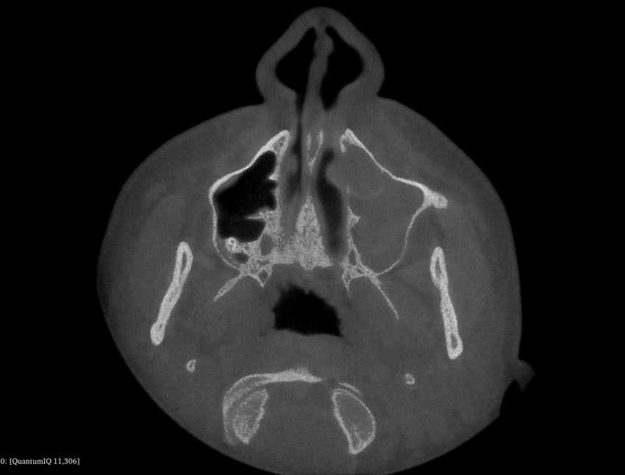
Figure 1: CBCT axial slice image of the FPM prior to segmentation.
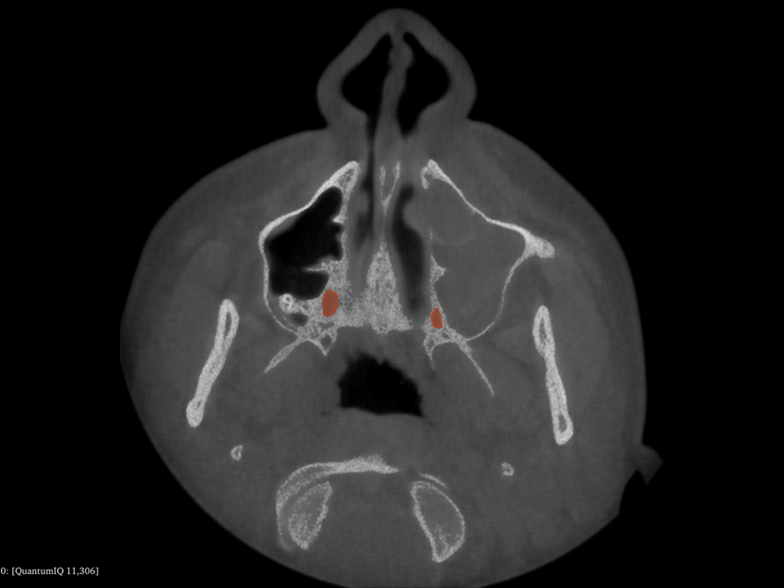
Figure 2: CBCT axial slice image of the FPM following segmentation.
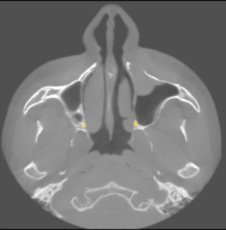
Figure 3: The dataset prior to preprocessing.
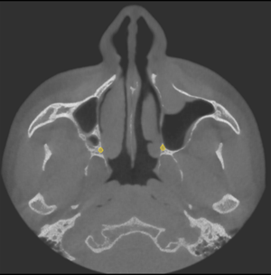
Figure 4: After sharpening process.
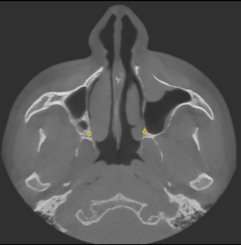
Figure 5: After data rescaling.
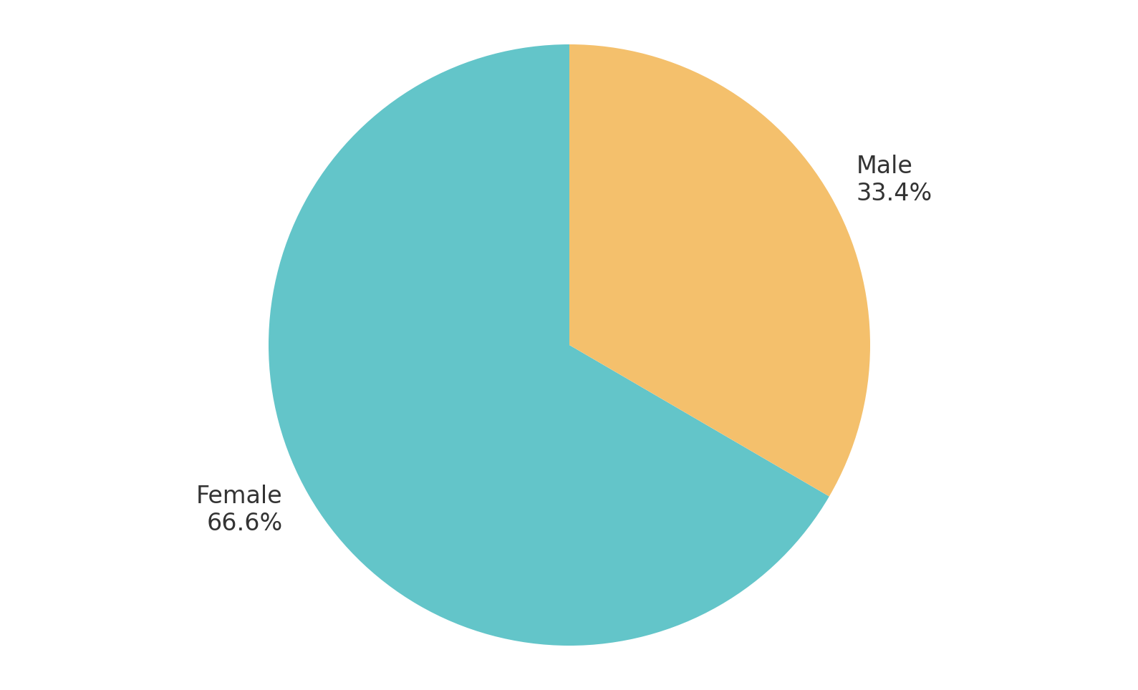
Figure 6: Gender distribution of patients from whom the CBCT images were acquired.
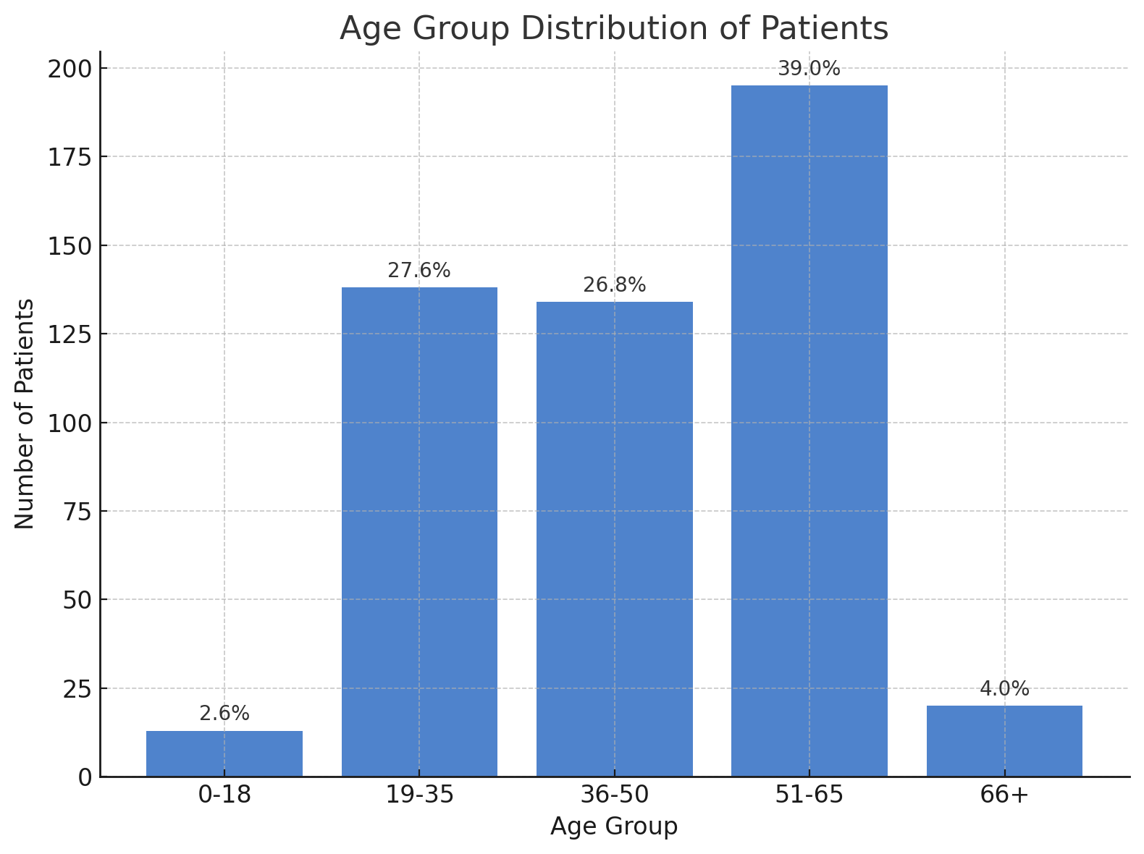
Figure 7: Age distribution of patients from whom the CBCT images were acquired.
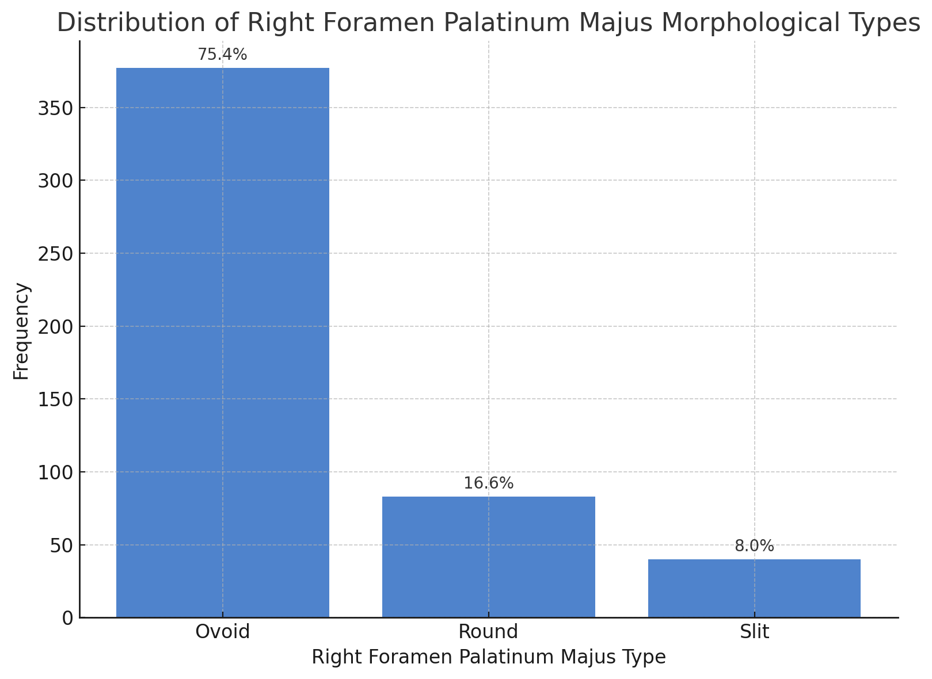
Figure 8: Distribution of FPM types in the right maxilla within the dataset.

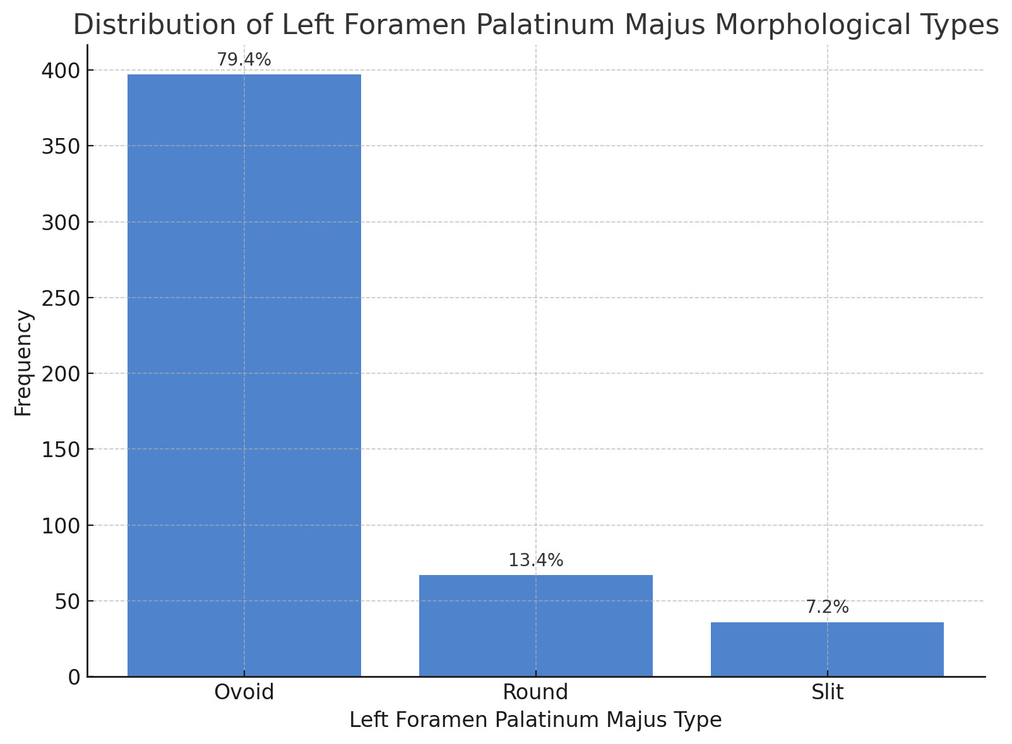
Figure 9: Distribution of FPM types in the left maxilla within the dataset.
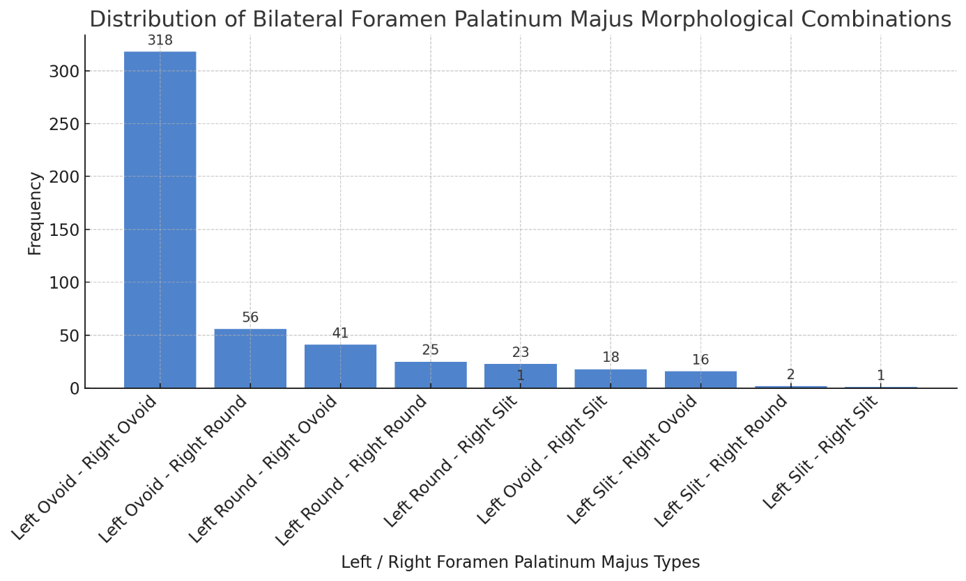
Figure 10: Distribution of FPM type combinations in the right and left regions within the dataset.
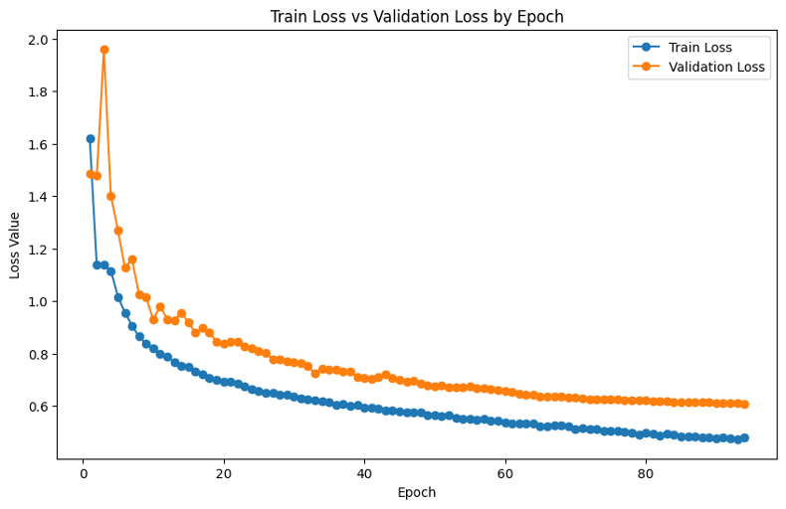
Figure 11: Training and validation loss curves.
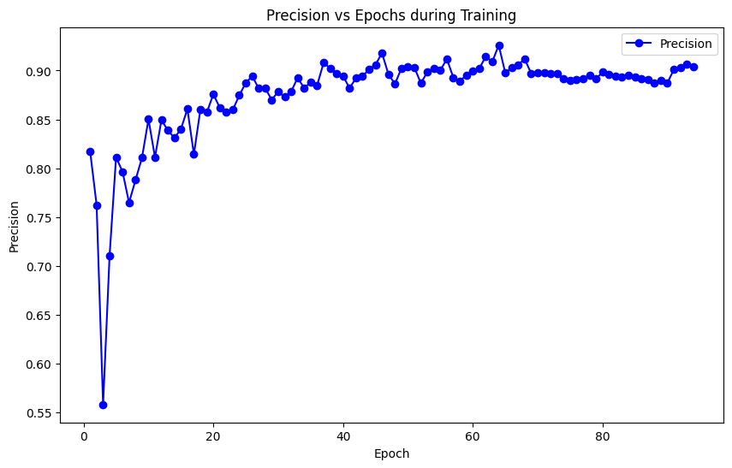
Figure 12: Precision graph per epoch.
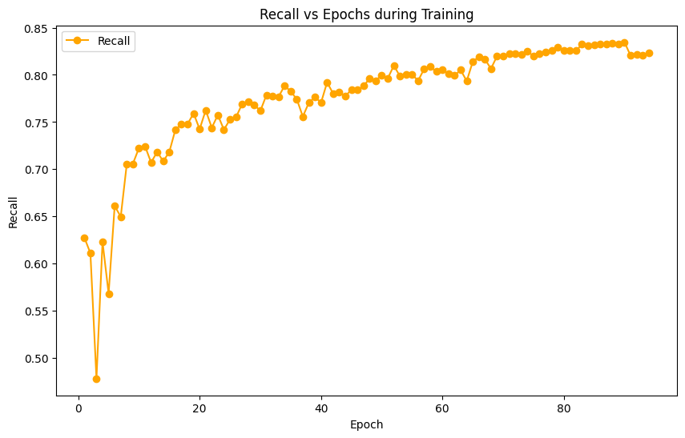
Figure 13: Recall graph per epoch.

REFERENCES
1. Scarfe WC, Farman AG. What is cone-beam CT and how does it work? Dental Clinics of North America. 2008;52(4):707-30.
2. Jaju PP, Jaju SP. Cone-beam computed tomography: Time to move from ALARA to ALADA. Imaging Sci Dent. 2015;45(4):263-5.
3. Alshomrani F. Cone-Beam Computed Tomography (CBCT)-based diagnosis of dental bone defects. Diagnostics. 2024;14(13):1404.
4. Drake R, Vogl AW, Mitchell AW. Gray's anatomy for students E-book: Elsevier Health Sciences; 2009.
5. Reiser GM, Bruno JF, Mahan PE, Larkin LH. The subepithelial connective tissue graft palatal donor site: anatomic considerations for surgeons. International Journal of Periodontics & Restorative Dentistry. 1996;16(2).
6. Rios O, Lerhe B, Chamorey E, Savoldelli C. Accuracy of segmented le fort I osteotomy with virtual planning in orthognathic surgery using patient-specific implants: a case series. Journal of Clinical Medicine. 2022;11(19):5495.
7. Malamed SF. Handbook of local anesthesia: Elsevier Brasil; 2004.
8. Methathrathip D, Apinhasmit W, Chompoopong S, Lertsirithong A, Ariyawatkul T, Sangvichien S. Anatomy of greater palatine foramen and canal and pterygopalatine fossa in Thais: considerations for maxillary nerve block. Surgical and Radiologic Anatomy. 2005;27:511-6.
9. TAŞSÖKER M, AZMAN D, KABAKÇI ADA. Morphometric analysis of the foramen palatinum majus by cone-beam computed tomography. 2023.
10. Akkitap MP. Morphology and morphometry of the greater palatine foramen: A radio‐anatomical study using cone‐beam computed tomography. Oral Surgery. 2025;18(1):56-62.
11. Lee J-S, Adhikari S, Liu L, Jeong H-G, Kim H, Yoon S-J. Osteoporosis detection in panoramic radiographs using a deep convolutional neural network-based computer-assisted diagnosis system: a preliminary study. Dentomaxillofacial Radiology. 2019;48(1):20170344.
12. Hiraiwa T, Ariji Y, Fukuda M, Kise Y, Nakata K, Katsumata A, et al. A deep-learning artificial intelligence system for assessment of root morphology of the mandibular first molar on panoramic radiography. Dentomaxillofacial Radiology. 2019;48(3):20180218.
13. Koca Ünsal RB, Orhan K. Diş Hekimliğinde Yapay Zeka Uygulamaları. Journal of Ankara University Faculty of Medicine/Ankara Üniversitesi Tip Fakültesi Mecmuasi. 2022;75.
14. Orhan K, Bayrakdar I, Ezhov M, Kravtsov A, Özyürek T. Evaluation of artificial intelligence for detecting periapical pathosis on cone‐beam computed tomography scans. International endodontic journal. 2020;53(5):680-9.
15. Ma J, He Y, Li F, Han L, You C, Wang B. Segment anything in medical images. Nature Communications. 2024;15(1):654.
16. Kirillov A, Mintun E, Ravi N, Mao H, Rolland C, Gustafson L, et al., editors. Segment anything. Proceedings of the IEEE/CVF international conference on computer vision; 2023.
17. Zhiqiang W, Jun L, editors. A review of object detection based on convolutional neural network. 2017 36th Chinese control conference (CCC); 2017: IEEE.
18. Jiang P, Ergu D, Liu F, Cai Y, Ma B. A Review of Yolo algorithm developments. Procedia computer science. 2022;199:1066-73.
19. Rohrer C, Krois J, Patel J, Meyer-Lueckel H, Rodrigues JA, Schwendicke F. Segmentation of dental restorations on panoramic radiographs using deep learning. Diagnostics. 2022;12(6):1316.
20. Jang TJ, Kim KC, Cho HC, Seo JK. A fully automated method for 3D individual tooth identification and segmentation in dental CBCT. IEEE transactions on pattern analysis and machine intelligence. 2021;44(10):6562-8.
21. Gardiyanoğlu E, Ünsal G, Akkaya N, Aksoy S, Orhan K. Automatic segmentation of teeth, crown–bridge restorations, dental implants, restorative fillings, dental caries, residual roots, and root canal fillings on orthopantomographs: Convenience and pitfalls. Diagnostics. 2023;13(8):1487.
22. Xiang B, Lu J, Yu J. Evaluating tooth segmentation accuracy and time efficiency in CBCT images using artificial intelligence: a systematic review and Meta-analysis. Journal of Dentistry. 2024:105064.
23. Dot G, Schouman T, Dubois G, Rouch P, Gajny L. Fully automatic segmentation of craniomaxillofacial CT scans for computer-assisted orthognathic surgery planning using the nnU-Net framework. European radiology. 2022:1-10.
24. Fontenele RC, do Nascimento Gerhardt M, Pinto JC, Van Gerven A, Willems H, Jacobs R, et al. Influence of dental fillings and tooth type on the performance of a novel artificial intelligence-driven tool for automatic tooth segmentation on CBCT images–A validation study. Journal of dentistry. 2022;119:104069.
25. Zhicheng H, Yipeng W, Xiao L. Deep Learning-Based Detection of Impacted Teeth on Panoramic Radiographs. Biomedical Engineering and Computational Biology. 2024;15:11795972241288319.
26. Organizers DC. Dentex Dental X-ray Dataset: Grand Challenge, Radboud University Medical Center; 2023 [Available from: https://dentex.grand-challenge.org/.
27. Ronneberger O, Fischer P, Brox T, editors. U-net: Convolutional networks for biomedical image segmentation. Medical image computing and computer-assisted intervention–MICCAI 2015: 18th international conference, Munich, Germany, October 5-9, 2015, proceedings, part III 18; 2015: Springer.
28. Isensee F, Jaeger PF, Kohl SA, Petersen J, Maier-Hein KH. nnU-Net: a self-configuring method for deep learning-based biomedical image segmentation. Nature methods. 2021;18(2):203-11.
29. Chen L-C, Zhu Y, Papandreou G, Schroff F, Adam H, editors. Encoder-decoder with atrous separable convolution for semantic image segmentation. Proceedings of the European conference on computer vision (ECCV); 2018.
30. Chen J, Lu Y, Yu Q, Luo X, Adeli E, Wang Y, et al. Transunet: Transformers make strong encoders for medical image segmentation. arXiv preprint arXiv:210204306. 2021.
31. Cao H, Wang Y, Chen J, Jiang D, Zhang X, Tian Q, et al., editors. Swin-unet: Unet-like pure transformer for medical image segmentation. European conference on computer vision; 2022: Springer.
32. Nazzal W, Thurnhofer-Hemsi K, López-Rubio E. Improving Medical Image Segmentation Using Test-Time Augmentation with MedSAM. Mathematics. 2024;12(24):4003.
33. Xue X, Liang D, Wang K, Gao J, Ding J, Zhou F, et al. A deep learning‐based 3D Prompt‐nnUnet model for automatic segmentation in brachytherapy of postoperative endometrial carcinoma. Journal of Applied Clinical Medical Physics. 2024;25(7):e14371.

